BILC Assignment 02

Mike Pendleton

West Texas A@M University

Select the Top 20 records for each class (three queries here) - Base the top 20 on your choice of any of the other fields - sepal length, sepal width, petal length, or petal width

Class Iris-setosa:

Class Iris-versicolor

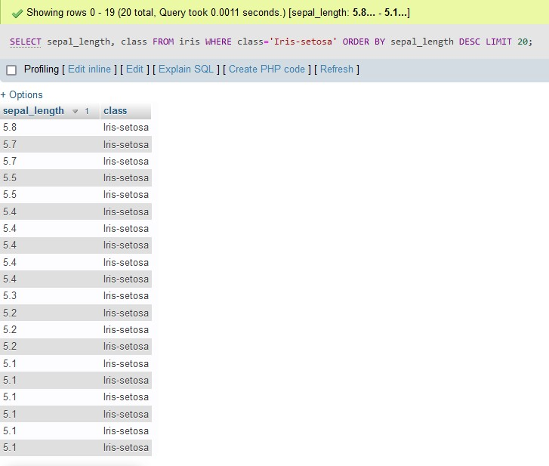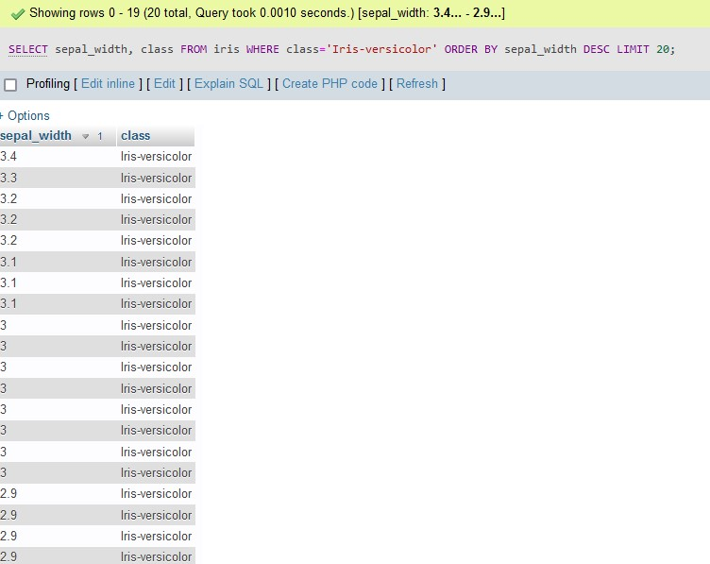

Class Iris-virginica

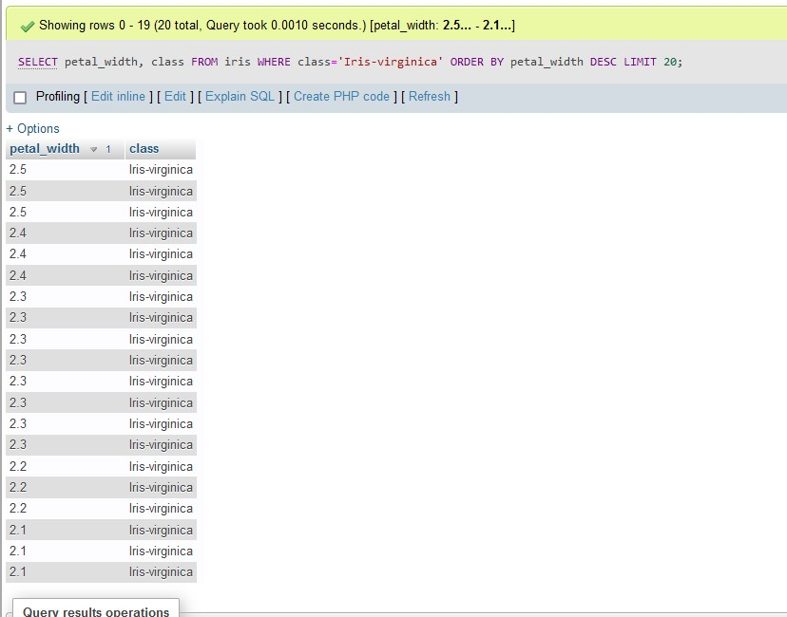

• Show the MIN and MAX for each class (three queries here)  - Base MIN and MAX based on your choice of any of the other fields - sepal length, sepal width, petal length, or petal width

Class Iris-setosa

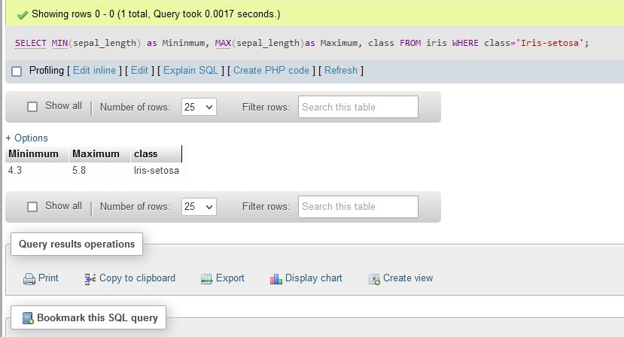

Class Iris-versicolor

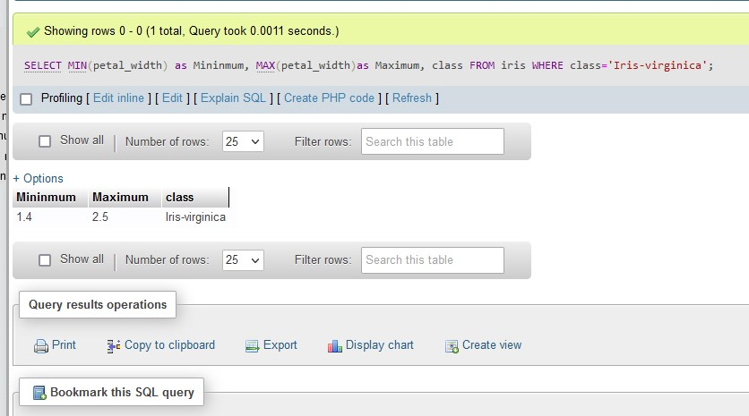

Class Iris-virginica

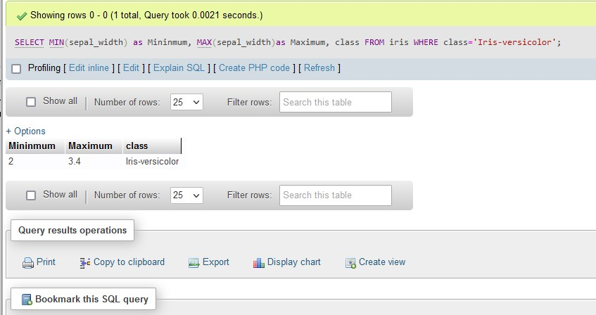

Show the AVG value for petal length and petal width for each class (three queries here)

Class Iris-setosa

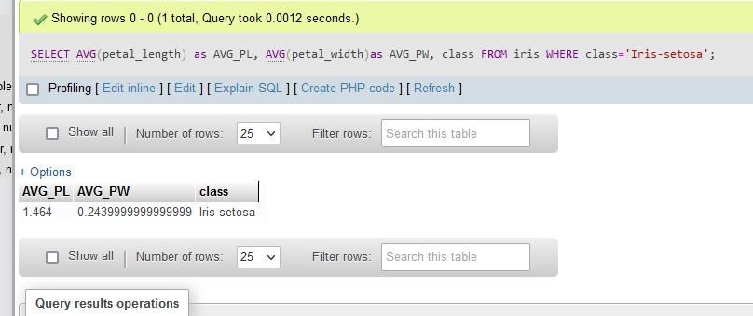

Class Iris-versicolor

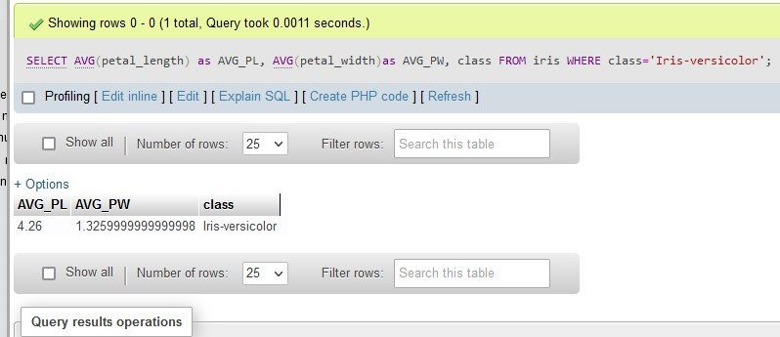

Class Iris-virginica

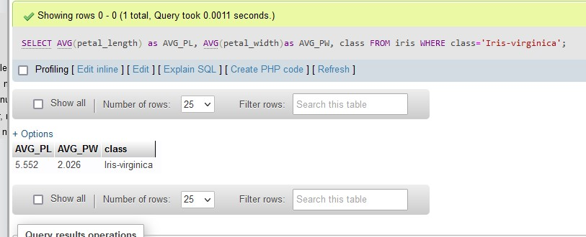

Show all values for sepal length and sepal height that are within +/-  one Standard Deviation from the mean of those values

I have used the query provided to try. The following is the result and interestingly enough there is not a numerical value returned.

My sql didn’t like the uptiks for some reason so I replaced them with single quotes. And then it complained and I found it was due to the spaces.

Modified version below:

SELECT 'sepal-length', 'sepal-width'

FROM iris

WHERE 'sepal-length' BETWEEN

(

SELECT AVG('sepal-length') - STDDEV('sepal-length')

FROM iris

)

AND

(

SELECT AVG('sepal-length') + STDDEV('sepal-length')

FROM iris

)

AND 'sepal-width' BETWEEN

(

SELECT AVG('sepal-width') - STDDEV('sepal-width')

FROM iris

Results are below:

